[Patient name] [Practice name]
[Patient address1] [Practice Address 1]

[Patient address 2] [Practice Address 2]
[Patient address 3] [Practice Address 3]

[Postcode] [Postcode]

[Date]

Dear Patient,
Changes to your inhaler
Your GP surgery continually reviews medicines to make sure that patients receive high quality and effective treatment that is best value, in line with latest national and local guidelines.

We are writing to you today to let you know of a change of brand for the inhaler you receive on your prescription. The full details of the changes are shown below. This new medication will be given to you when you collect your next repeat prescription.

WHAT YOU TAKE NOW | WHAT IT WILL CHANGE TO
Qvar® Inhaler  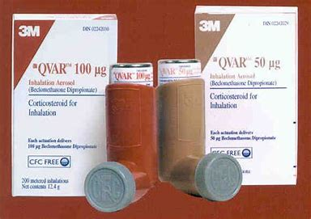 | Kelhale® Inhaler  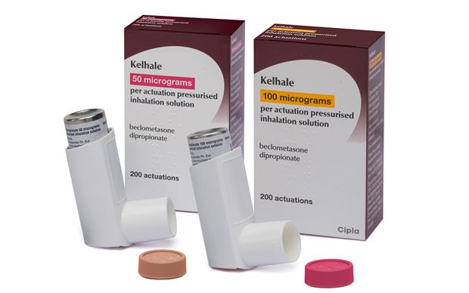

The new Kelhale® inhaler contains the same active ingredient as your previous Qvar® inhaler. You should use the Kelhale® inhaler in exactly the same way as your old inhaler. Please finish your old inhaler before starting on the new brand. This change does not mean that your condition or treatment has changed in any way. The Kelhale® inhaler will control your symptoms in the same way as your previous inhaler. Apart from the change in how it looks you should notice no difference at all.

If you are concerned or wish to discuss the matter further, please do not hesitate in contacting the practice or your local community pharmacist.

While writing I would like to take this opportunity to remind you to only order the medicines you need each time you resubmit your repeat prescription request.

Yours sincerely,

